***Q1: Calculate the time for each process, define the priority?***

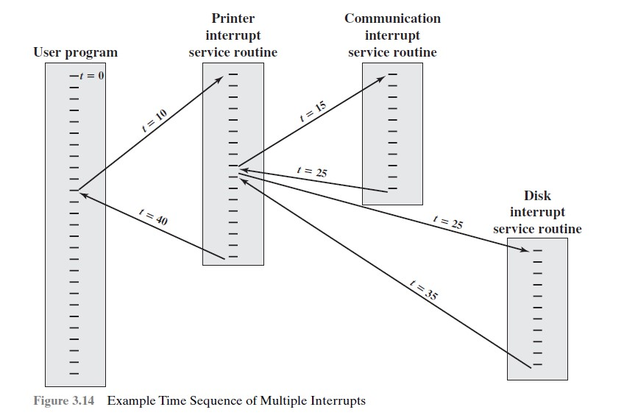

***Answer:***

*A user program begins at t =0. At t =10, a printer interrupt occurs, while this routine is still executing, at t=15, a communications interrupt occurs and execution continues at the communications ISR. While this routine is executing, a disk interrupt occurs at t= 20. When the communications ISR is complete (t =25), the previous processor state is restored, which is the execution of the printer ISR. Then, processor honors the higher priority disk interrupt and control transfers to the disk ISR. Only when that routine is complete (t =35) is the printer ISR resumed. When that routine completes (t =40), control finally returns to the user program. So, time without interrupt would be 10 t, but with interrupt it will increase 30 t then: time =40 t*

***The priority:***

*Printer=priority 2*

*Communication= priority 5*

*Disk = priority 4*

